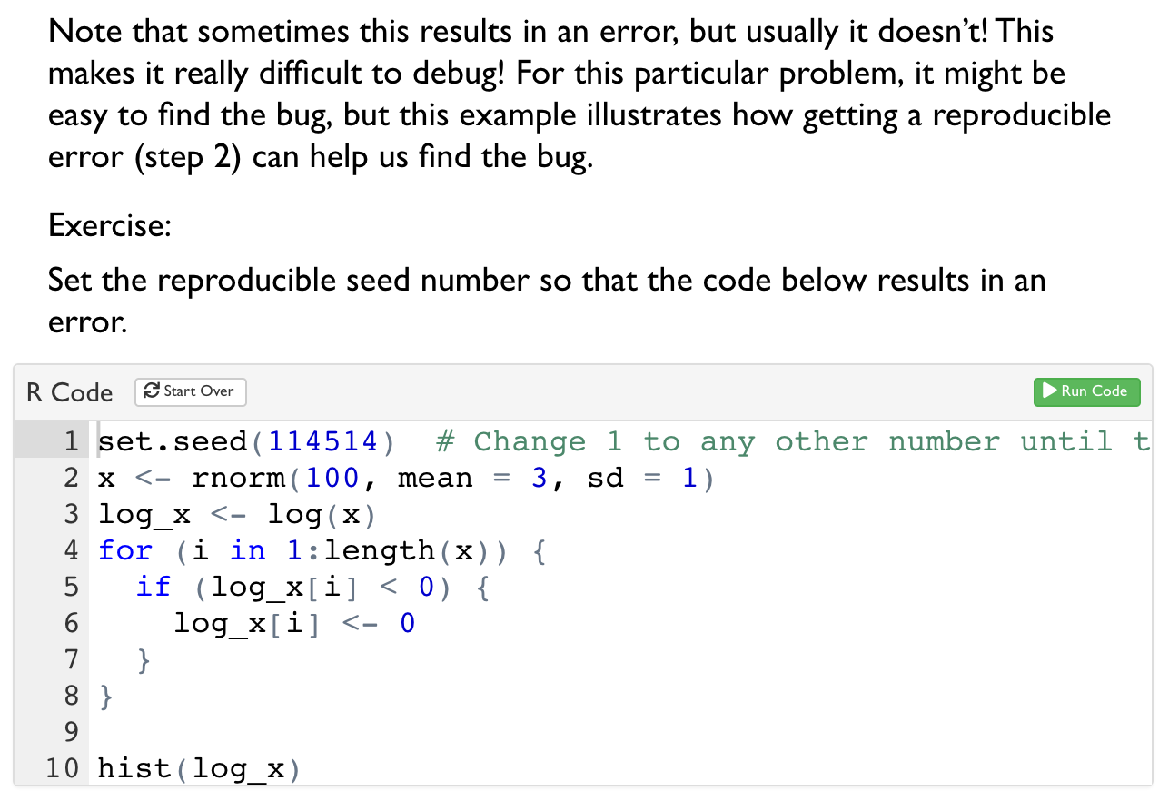

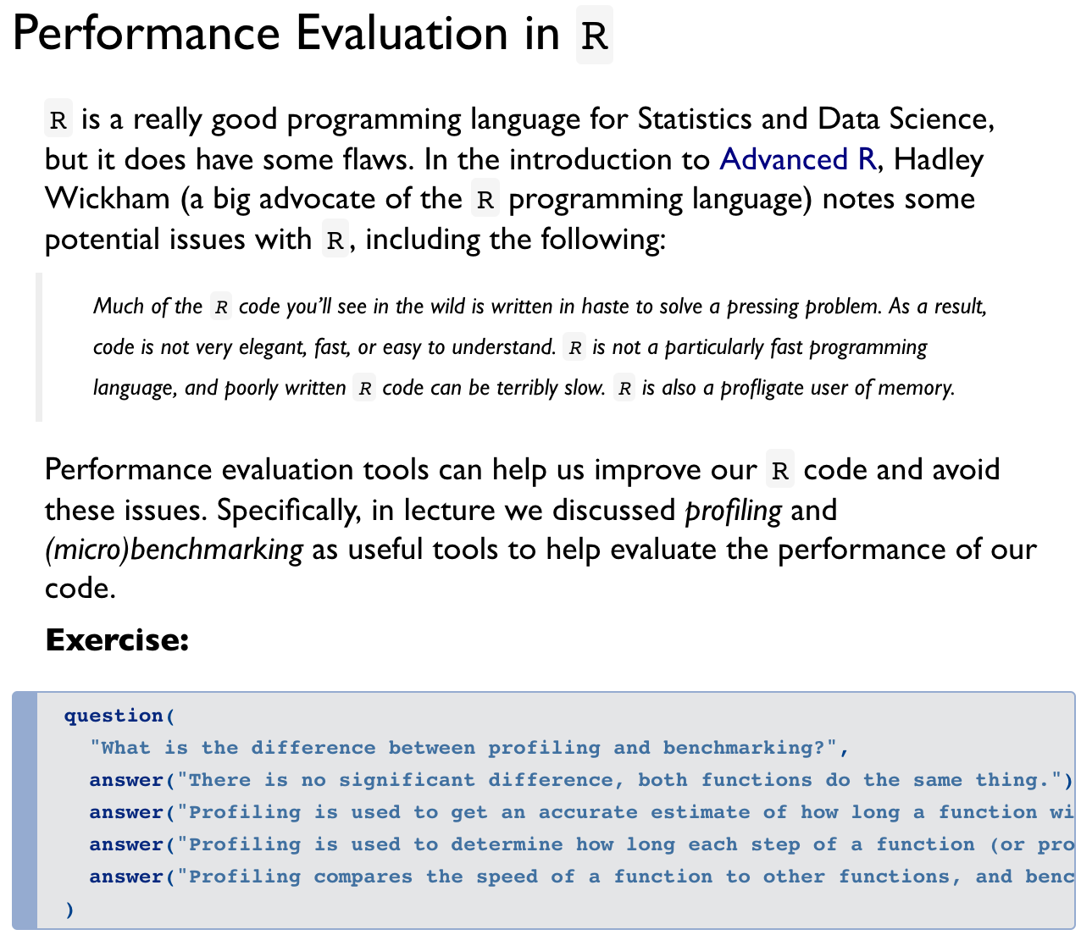

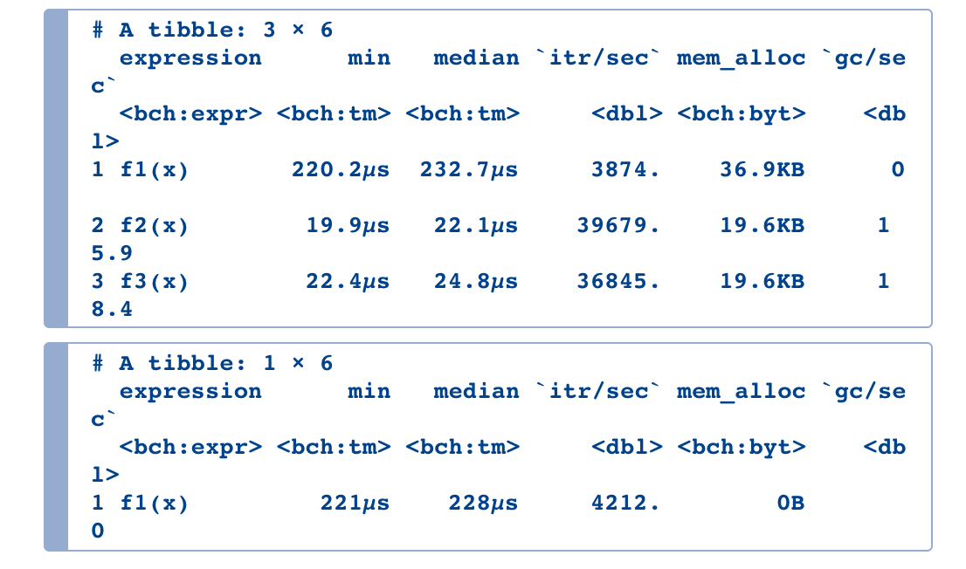

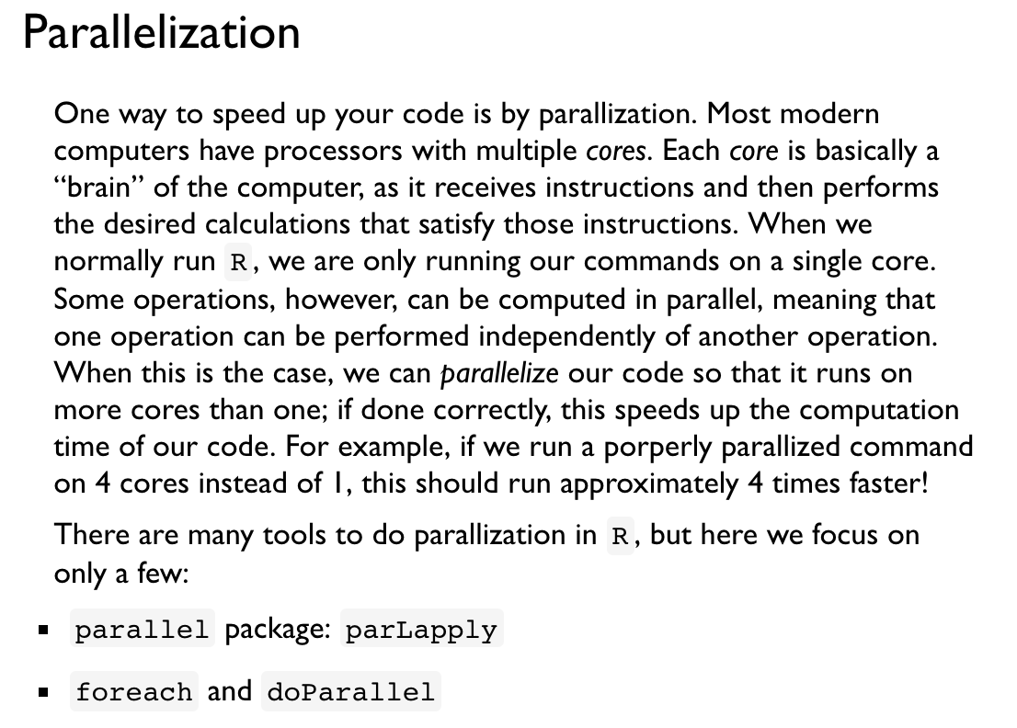

‘’’ {R} stopCluster(cl)’’’

